# Basic Analog Integrated Circuits

Written by Mark Webster

***Summary***

Learn to make some common analog electronic circuits such as audio amplifiers, timers, and voltage regulators.

## Introduction

An analog circuit uses voltages that vary anywhere between ground and Vcc. Digital circuits are all or nothing, HIGH or LOW, 1 or 0.

The physical world is mainly analog. Sound is analog pressure waves. Radio and light are analog electromagnetic waves. Earthquakes are analog seismic waves. Movement is analog mechanical force. Sensors and motors are analog so there must be circuitry to go between the analog world and digital devices like microcontrollers or computers.

Analog circuits are older than digital. Before digital computers analog circuits and even analog computers were common. Many digital devices such as smartphones still have analog circuitry within them for the microphone input, headphone output, radio transceiver, and wi-fi reception.

The simplest analog circuit would be a potentiometer between Vcc and ground, with the voltage on the middle pin varying between minimum and maximum. More complicated analog circuits are packaged as an integrated circuit to create devices with fewer part counts.

## Audio Amplifiers

Simple analog audio amplifiers are often used in guitar pre-amps, Arduino MP3 players, radio amplifiers, AM-FM radios, servo drivers, oscillators, and noise generators. Audio amplifiers are necessary for a microprocessor like an Arduino to drive a speaker since the current supplied by output pins is too low to drive a high powered device like a speaker.

There are many audio modules available. A single power transistor can be used. But for more fidelity and gain an integrated circuit is used. A LM358 op amp chip as a very low power audio amplifier, although to drive a speaker the more powerful LM386 is preferred.

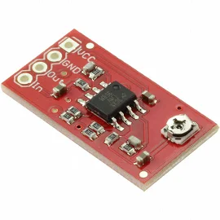Sparkfun Electronics BOB-09816

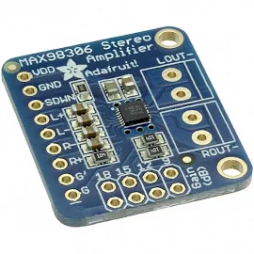Adafruit Industries Llc 987

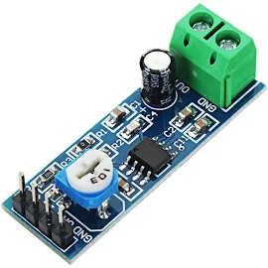

Banggood LM386 Audio Amplifier Module 200 Times Input 10K Adjustable Resistance

### LM386

The simplest audio mono amplifier is a single low cost LM386 chip with a couple of resistors and capacitors. By using a potentiometer as a voltage divider at the input, the LM386 can be variable gain. The chip works over a wide voltage range, from 5V to 18V, single supply, so it is good for battery based devices. The gain can be from 20 to 200. It is low distortion for its cost. With a few more capacitors and resistors, bass boost can be added.

<https://en.wikipedia.org/wiki/LM386> (and article)

<http://www.ti.com/lit/ds/symlink/lm386.pdf> (the datasheet)

### Exercise 1: LM386

***Hardware***: breadboard, jumper wires, alligator clips for the speaker, LM386, earbuds, potentiometer, 0.5 capacitor, 220 capacitor, 10K resistor, function generator for input, 9V power supply

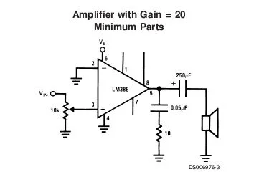

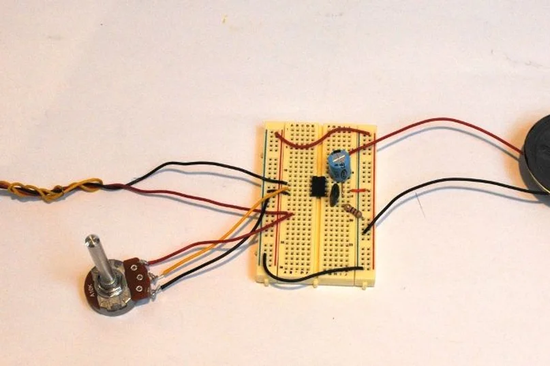

The better the speaker, the better the system will sound. The output capacitor blocks shifting DC levels to the speaker.

An faster circuit to assemble, less prone to induced noise uses a pre-soldered LM386 module.

***Hardware***: breadboard, jumper wires, LM386 audio module, function generator, 3.5mm socket, earbuds, 10K and 100 ohm resistors. The 10K and 100 ohm resistors are set up as a resistor divider circuit to reduce the input signal 100 times. Other resistor values may be used as long as the ratio is over 100.

A function generator makes signals such as sine wave, triangle or square wave. The resistor divider drops the voltage 100 times. The audio amp has a Vcc, ground, and a signal input and ground. The output of the audio amp has a ground and one signal out. Both the tip and ring of the 3.5mm socket are connected to signal out.

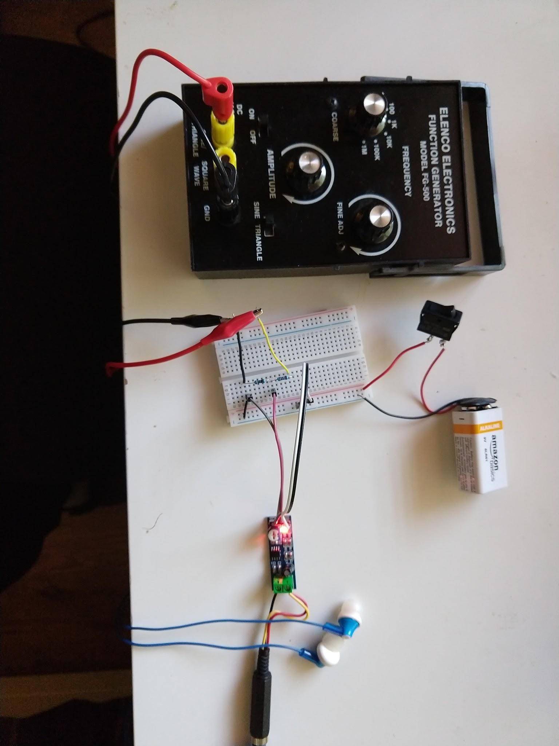

## Timers

Timer chips or modules produce pulses at regular intervals, or a single pulse for a certain length of time. Many such modules and chips exist. 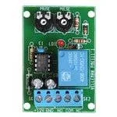Adjustable Interval Timer Kit, MK111, Velleman from Jameco.com

### 555 Timer

The least expensive and most common timer chip is 555 chip, which also comes in a dual timer package the 556.

<https://en.wikipedia.org/wiki/555_timer_IC>

There are two main uses for a 555 timer: monostable and astable.

The monostable mode creates an output pulse a fixed length of time after it is started.

The astable mode produces a continuous stream of pulses at a fixed interval.

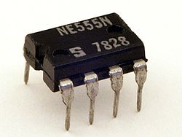

ASTABLE Mode

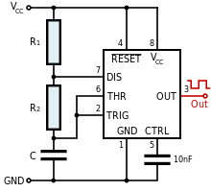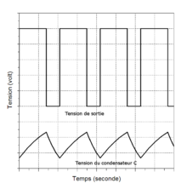



In theory any combination of resistors and capacitor will work. In practice, the R1 resistor must be high enough (over 500 ohms) to limit the current entering the the 555 timer chip to prevent overheating and burnout.

### Exercise 2: Astable 555 Timer

***Hardware***: Breadboard, 555 chip, led, 10 nF capacitor, jumper wires, capacitor, two 1K resistors. Other combinations of resistors and capacitor will work. Just try to make the frequency something the human eye can see, less than 10 hz. Also, be sure the resistor R1 is over 500 ohms to limit current into the timer.

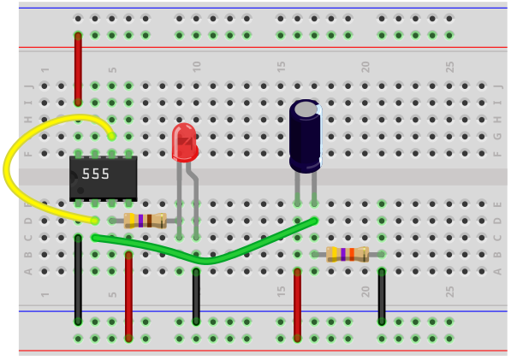

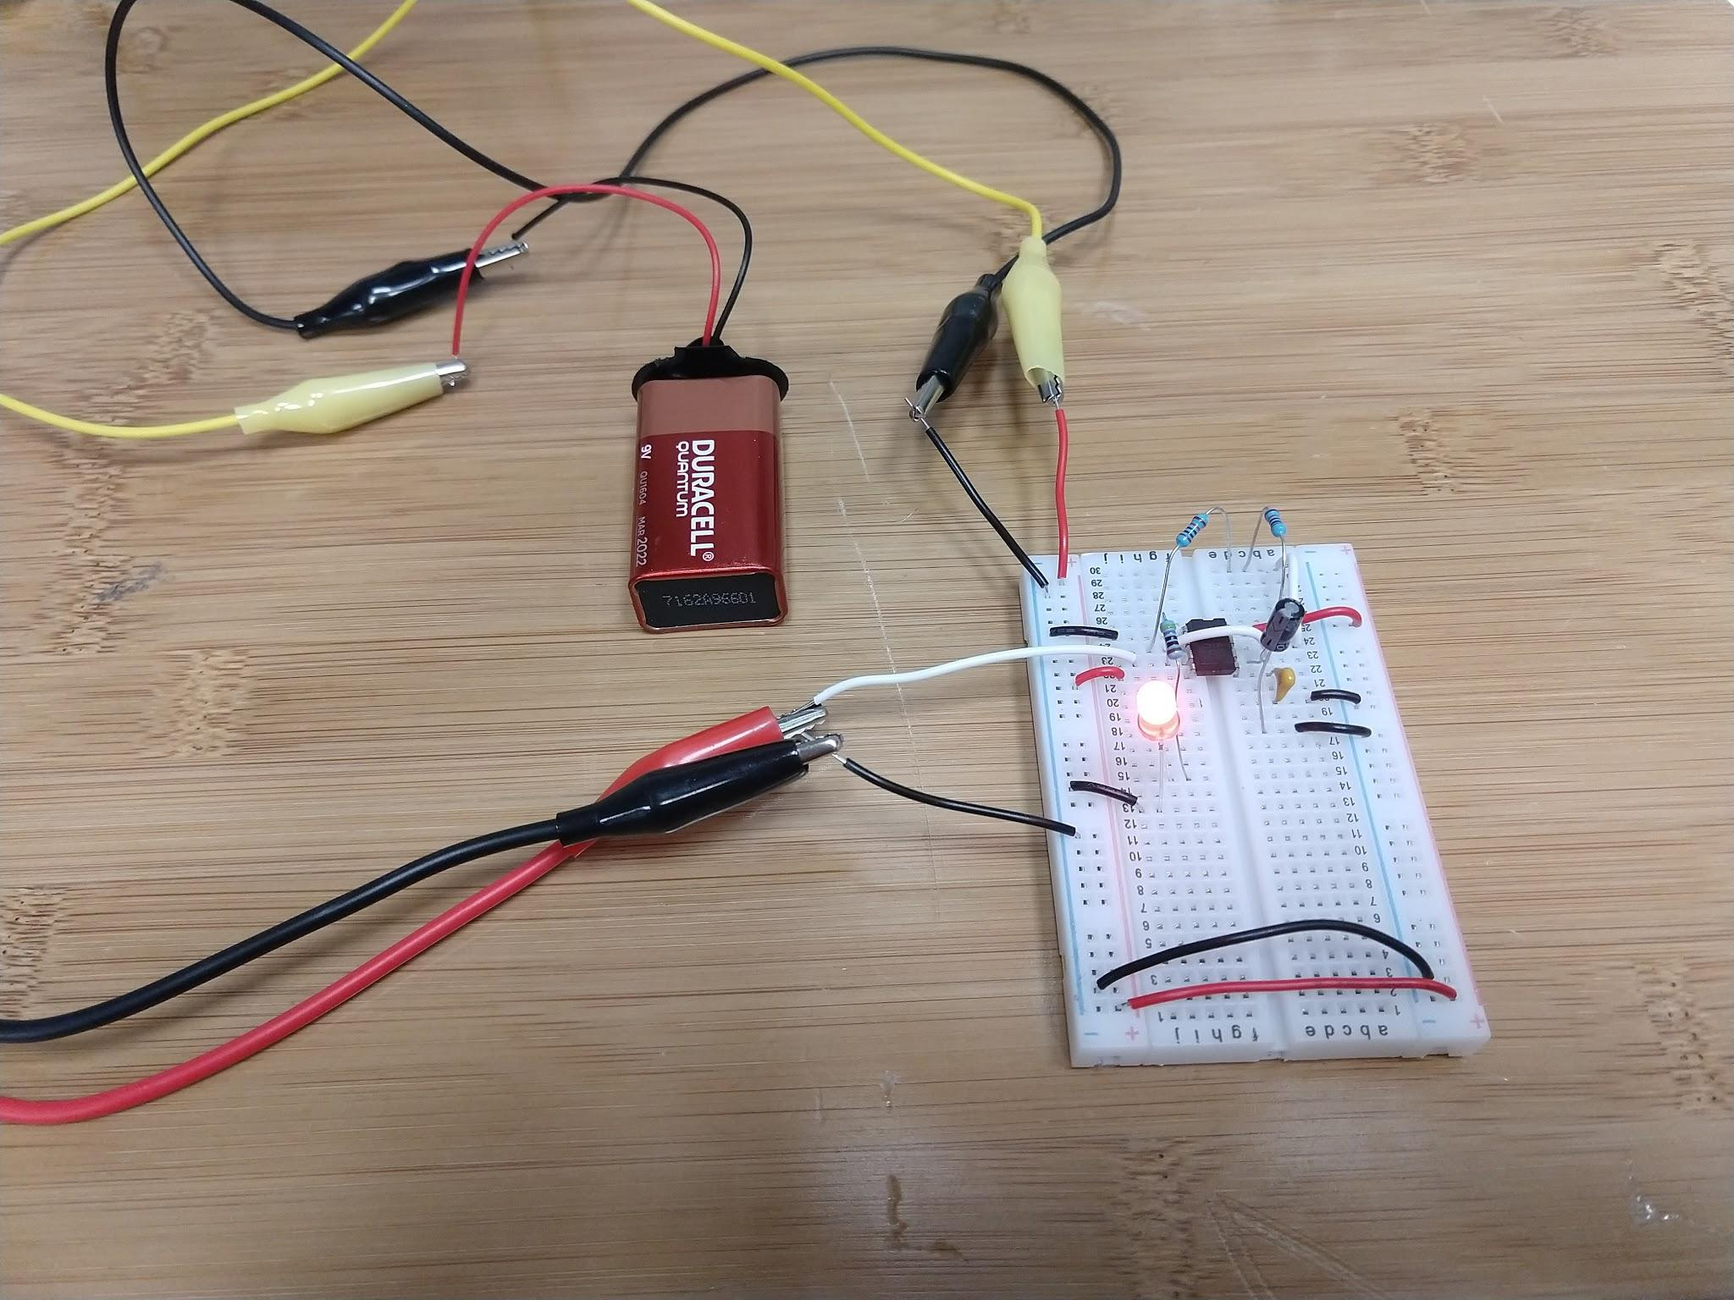

Monostable Mode

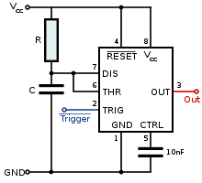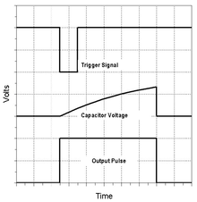

## Voltage Regulators

Stable DC power supplies are required for most consumer and commercial electronics devices.

Unfortunately, the most commonly available power sources such as AC wall current, solar power, battery power, are not steady voltage and often are alternating not DC current. A voltage regulator circuit will make an output voltage that is steady and consistent.

Alternating wall current (120V, 60 hz in America) can be converted with a transformer to a more usable voltage such as 20 V, 12 V or 5V, but it is still alternating current. A full wave rectifier will make the AC into pulsing DC, but it isn’t a smooth and stable DC that most devices require. The last step of the power supply is to smooth out the pulsations with a voltage regulator.

<https://en.wikipedia.org/wiki/Voltage_regulator>

Voltage regulation has been needed since the dawn of electronics, so there many methods have been devised. For very low power draw, even a zener diode can work as a voltage regulator.

We’ll focus here on the fixed voltage regulator chips in the 78xx series.

### 78xx Series of Voltage Regulators

The 78xx regulators have a fixed positive voltage specified by the last two digits. For example, 7805 produces a +5V stable output. The 79xx regulators produce a fixed negative voltage, used in some analog circuits that require a symmetric +- dual voltage, for instance +- 12 volts is common. There are also voltage regulators whose output voltage can be adjusted.

A 7809 or 7805 can be connected to a car battery and the 12V will be regulated down to 9 or 5 volts.

Note: a linear 78xx voltage regulator converts the voltage drop into heat. So a 12 volt to 9 volt regulator will get quite warm. Other types of more complicated voltage down converters are more efficient.

<https://en.wikipedia.org/wiki/Linear_regulator>

### Exercise 3: A 5 Volt Supply

***Hardware***: LM7805 ic, 1 𝛍F, 220 𝛍F, jumper wires, 9V battery, multimeter

Many hobbyist electronic circuits run off a 9V battery yet digital ICs and microprocessors often require a lower 5 V supply. Analog voltage regulators form a simple circuit to make a choppy voltage steady, and also to lower a voltage from a higher to a lower level. When the input voltage changes, such as with a battery or solar panel, the voltage regulator keeps the output steady,

For a single fixed output voltage the chips used are labeled LM 78xx where the “xx” is the output voltage. For example, LM7805 would be a +5 volt output.

One can start with a “wall wort” power supply that outputs some pulsating current over 10 V. That dirty power (pulsing) can be the input to a 7805 chip and come out clean (stable and regulated).

Only two capacitors must be added to make a stable, not fluctuating,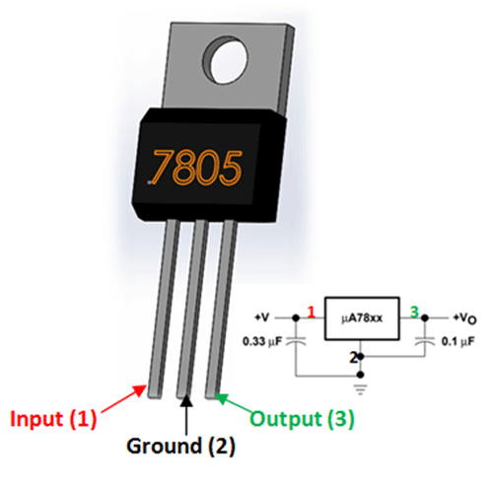

output. The exact values of the capacitors aren’t critical. Generally the higher farad ratings are better, although they are bigger and more expensive. If high current draw is needed, then a heat sink must be attached to the 7805 chip.

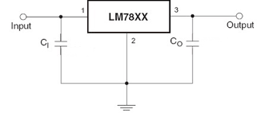

In our example we used higher value capacitors than is needed to produce an even cleaner output. For example, a 1 𝛍F on the input and a large 220 𝛍F on the output. If the input voltage is clean then much lower values can be used.

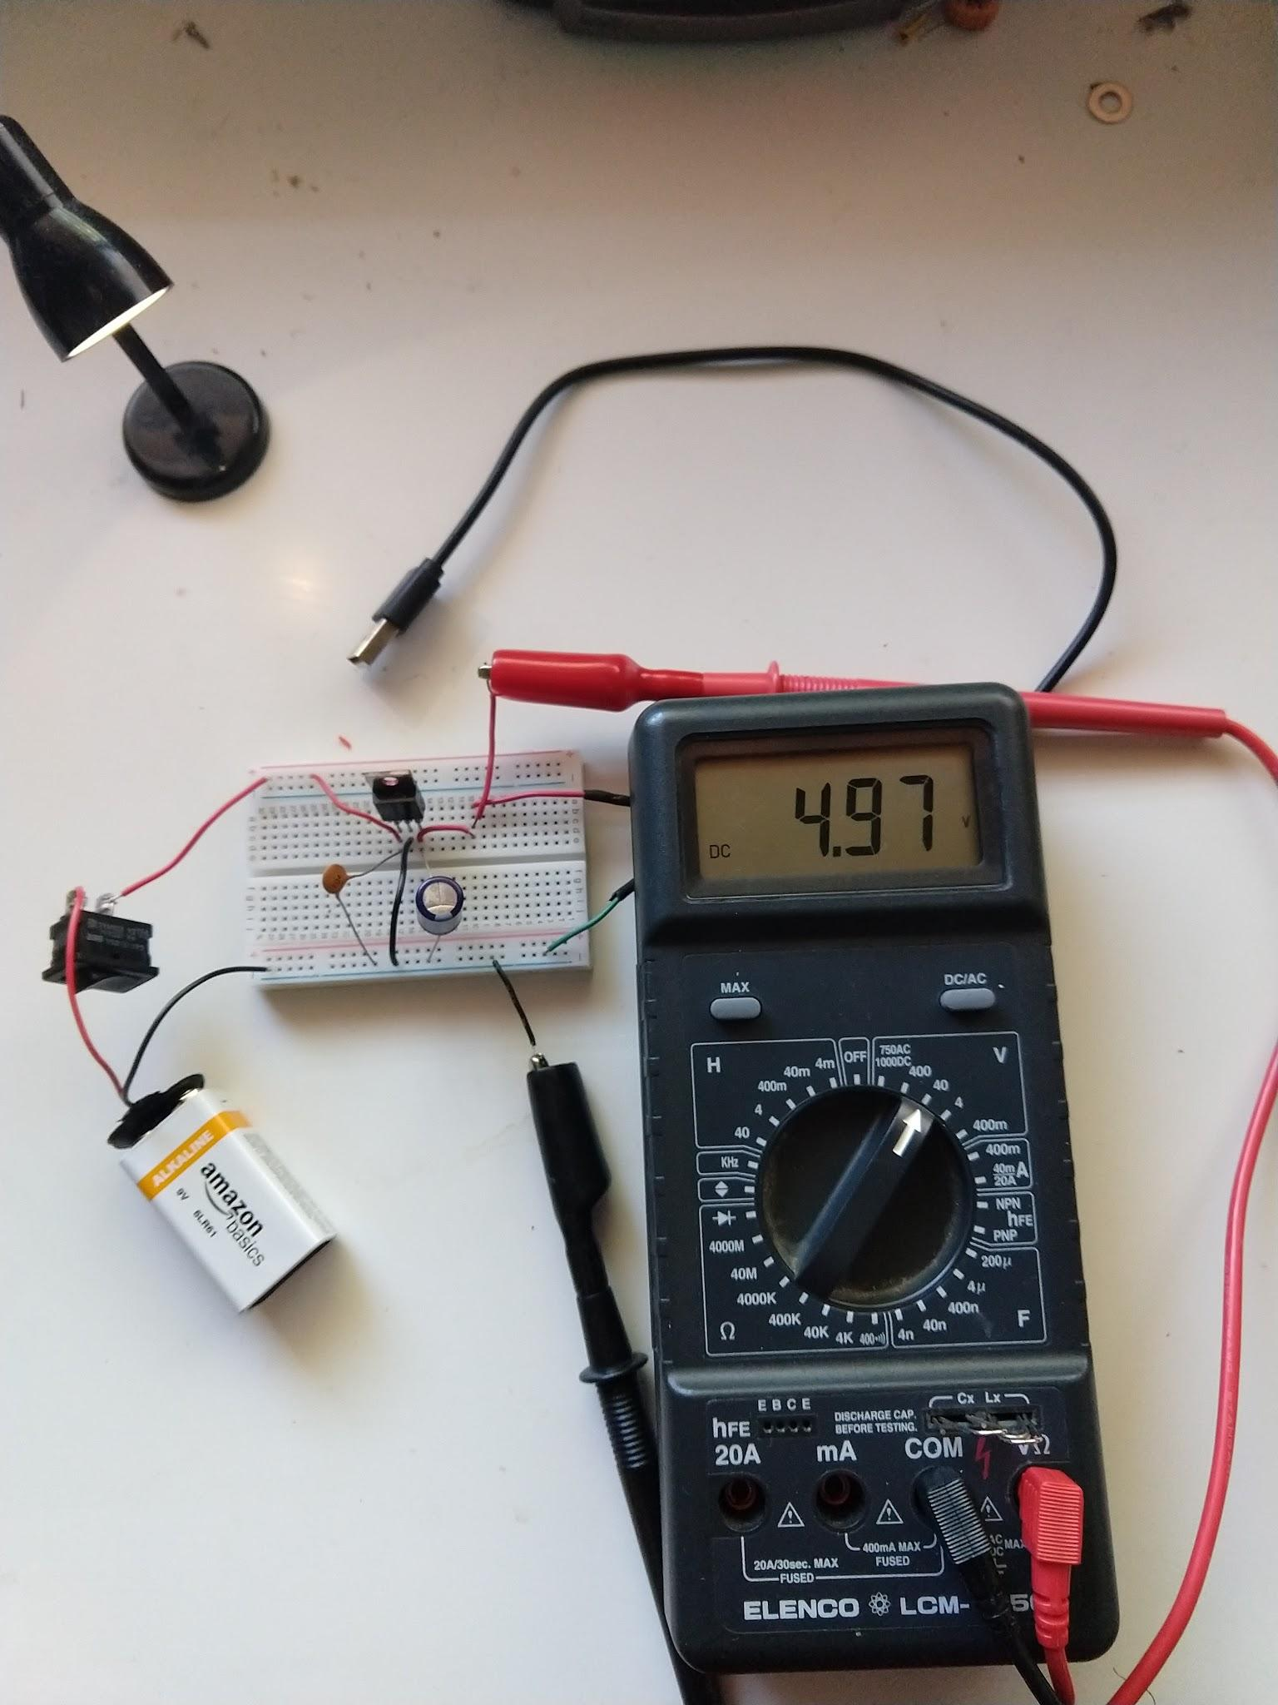

In this photo the output of the LM7805 is connected to a USB jack to power standard electronics devices.

If a complete solution is needed without a “wall wart”, then a transformer and 4 diodes (or a full wave rectifier) is needed.

## Function Generator

Most electronics labs have a function generator.

These electronics tools can be expensive benchtop units costing hundreds of dollars:

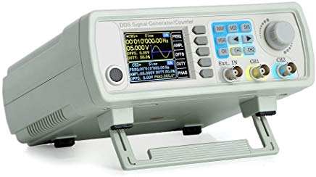

Function generators can be simple kits like:

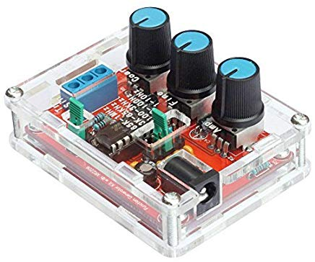

Or a function generator can be made from a single chip like XR-2206

